Backwater Demographics
Capture and remote sensing (PIT Scanning) records recorded in the Lower Colorado River Native Fishes Database (hereon referred to as “the database”) were used to provide demographic parameters (survival and population size) for populations of bonytail and razorback sucker in Yuma Cove backwater and Imperial Ponds (IPCA 1-6). Post-stocking survival was assessed with logistic regression based on PIT scanning data. The PIT tagged population of each backwater was estimated with the modified Peterson mark-recapture formula. Continuous scanning data was also used to calculate the number of “known survivors” over time. In backwaters with nearly continuous PIT scanning, these known survivor numbers should be no less than 95% of the actual PIT tagged population (refs).
Post-stocking survival was assessed using the glmmTMB package in R, which is a generalized linear model that can handle mixed models (fixed and random factors). Sex, total length (TL) at release were fixed independent factors in the model for all backwaters. Release year was added as a fixed factor for Yuma Cove backwater (2013 and 2014 release years). IPCA ponds with razorback sucker were modeled together with location (pond) added as a fixed factor, and IPCA ponds with bonytail were modeled together in the same way. Although all IPCA ponds had more than one release (stocking), all but the first stocking (since 2015) was removed from analysis due to a lack of post-stocking scanning (2024 stockings) or due to a lack of sexing data (unknown sex). Razorback sucker data for 2015 stocking in Yuma Cove backwater was removed from analysis because there was no encounter data for stocked males. Survival was treated as a binomial dependent where a fish was labeled as a survivor (1) if it was contacted via PIT scanners at least once 90 days or more after release, otherwise the fish was considered dead (0). All backwater models were additive only (no interaction effects).
Known survival analysis used PIT scanning data to track the number of PIT tagged fish alive in the backwater on any given date. Individual fish were coded as a survivor on a given date if it was tagged and released prior to that date (x-axis), and it was recorded on a PIT scanner at least once 90 days after its release date. Fish that were PIT scanned within a few days of tagging but died before contributing significantly to the population would therefore be excluded from the “known population”. For example, a fish tagged and released on January 1, 2019, will be included in the known population total for every day after January 1, 2019, if it was scanned once after May 1, 2019. If it was never scanned again after May 5, 2019, then it will be a part of the known population from January 1, 2019, through May 5, 2019, and removed from the known population for all subsequent dates. The advantage of this analysis over mark-recapture estimates is it provides individualized data that can be matched with genetic analysis to determine if parent-offspring pairings align with tagged parent survivor data. Also, known survivors can be categorized by any variable collected at tagging (e.g. sex), providing additional longer-term information on pre-release factors of survival.
Annual modified Peterson single-census mark recapture population estimates where calculated for all backwaters based on PIT scanning data:
$N^{*}=\frac{(M+1)(C+1)}{R+1}$ (Ricker 1975)

These estimates were for PIT tagged fish only. Fish had to be stocked or captured and tagged to be included in these estimates as only fish that were stocked or handled could be included in adult genetic analysis and known population analysis. The marking period was January through February of each year. For a fish to be included, it must have been tagged at least 6 months prior to the marking period. The capture period was from October through April. Fish must have been tagged 15 months prior to the start of the capture period, which coincided with the criteria for the marking period. The mark and capture periods as well as the formula for the estimates was the same used for reporting standardized population estimates within the lower Colorado River for the LCR MSCP (e.g. Downey et al. 2025).

Post-stocking survival as determined by PIT scanner detections for razorback sucker stocked in 2013 and 2014 was dependent on TL, sex, and release year, although the TLs released in 2014 had minimal range and likely had little influence on model results. Females were also released at a larger size on average then males, increasing the probability of post-stocking detection of female razorback sucker.
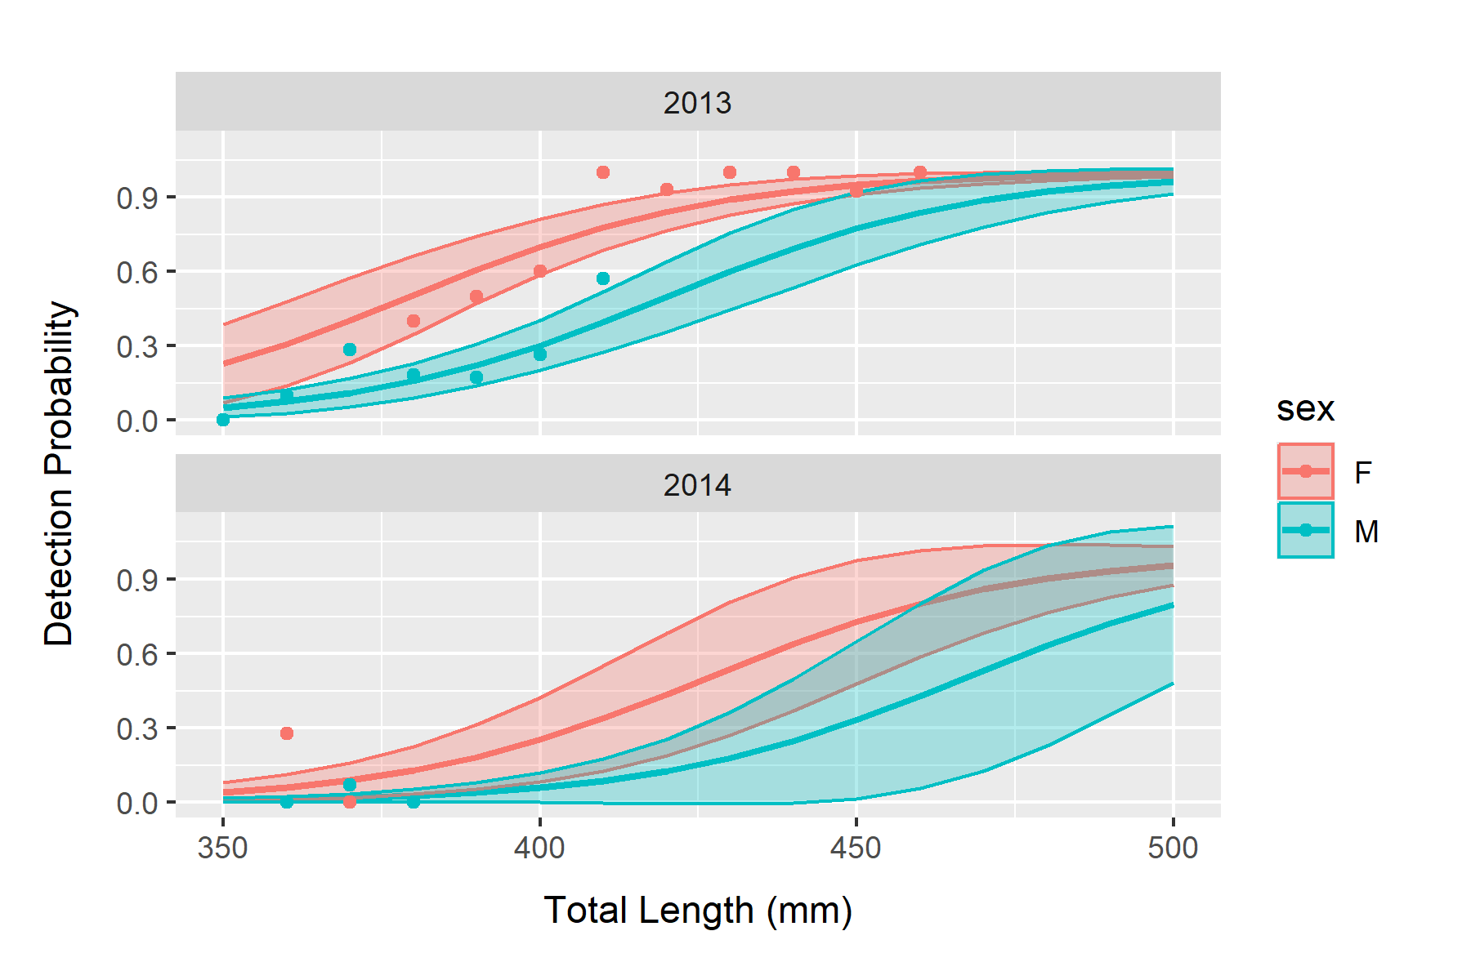
IPCA ponds with razorback sucker had similar results and release size discrepancies.
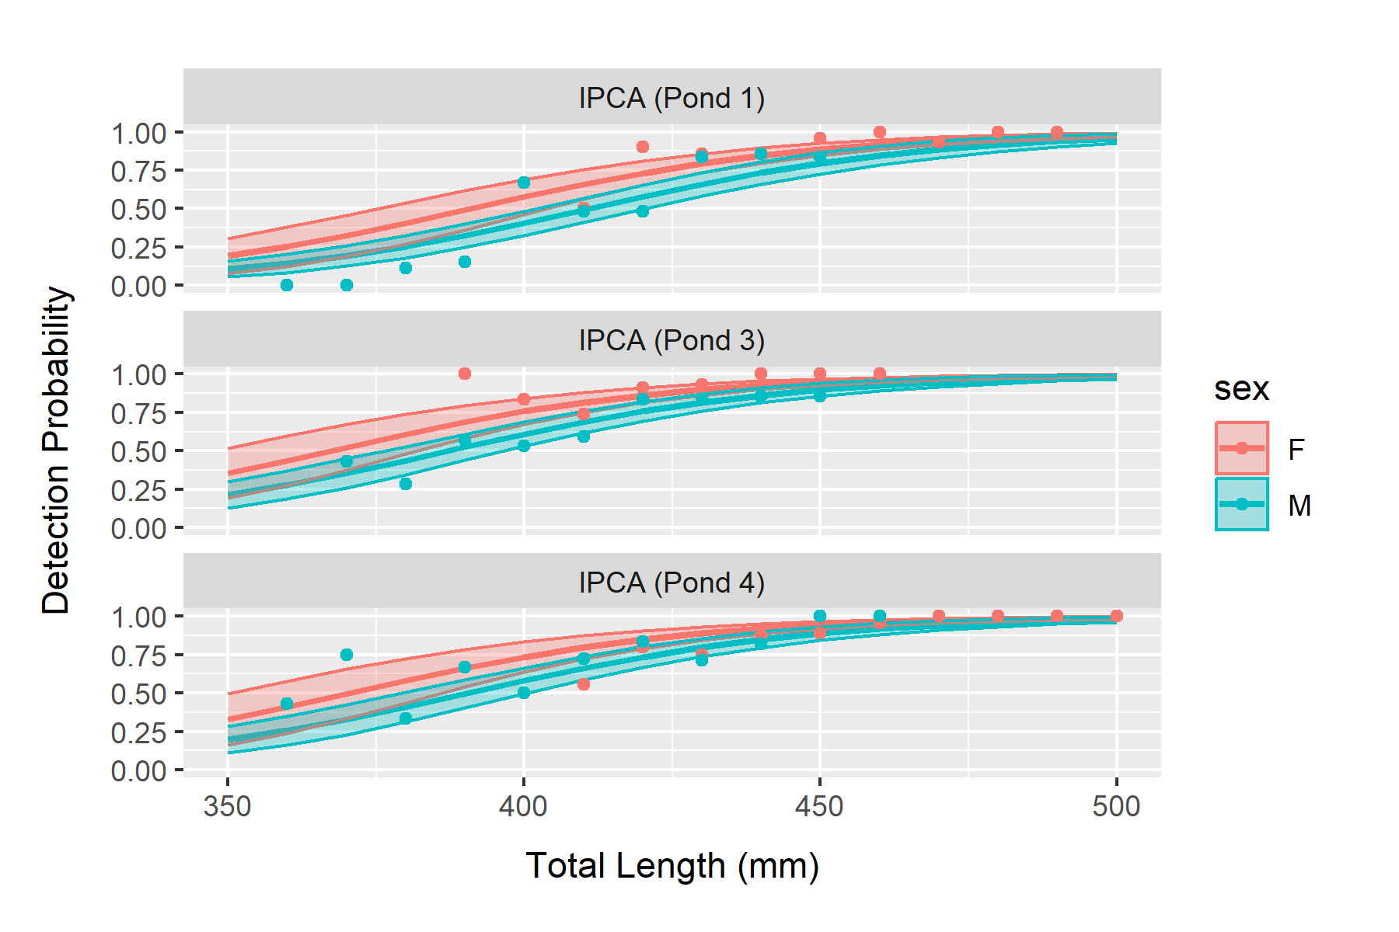

Sex and release size (TL) had no apparent impact on detection probability for bonytail. Although the range of TL at release is much narrower than it is for razorback sucker (between 240 mm to 290 mm compared to 350 mm to 500). Post-stocking survival for the smaller bonytail was also much higher relative to the smallest razorback sucker even though the largest bonytail was 50 mm shorter than the smallest razorback sucker. There was also little difference in mean release size between male and female bonytail.
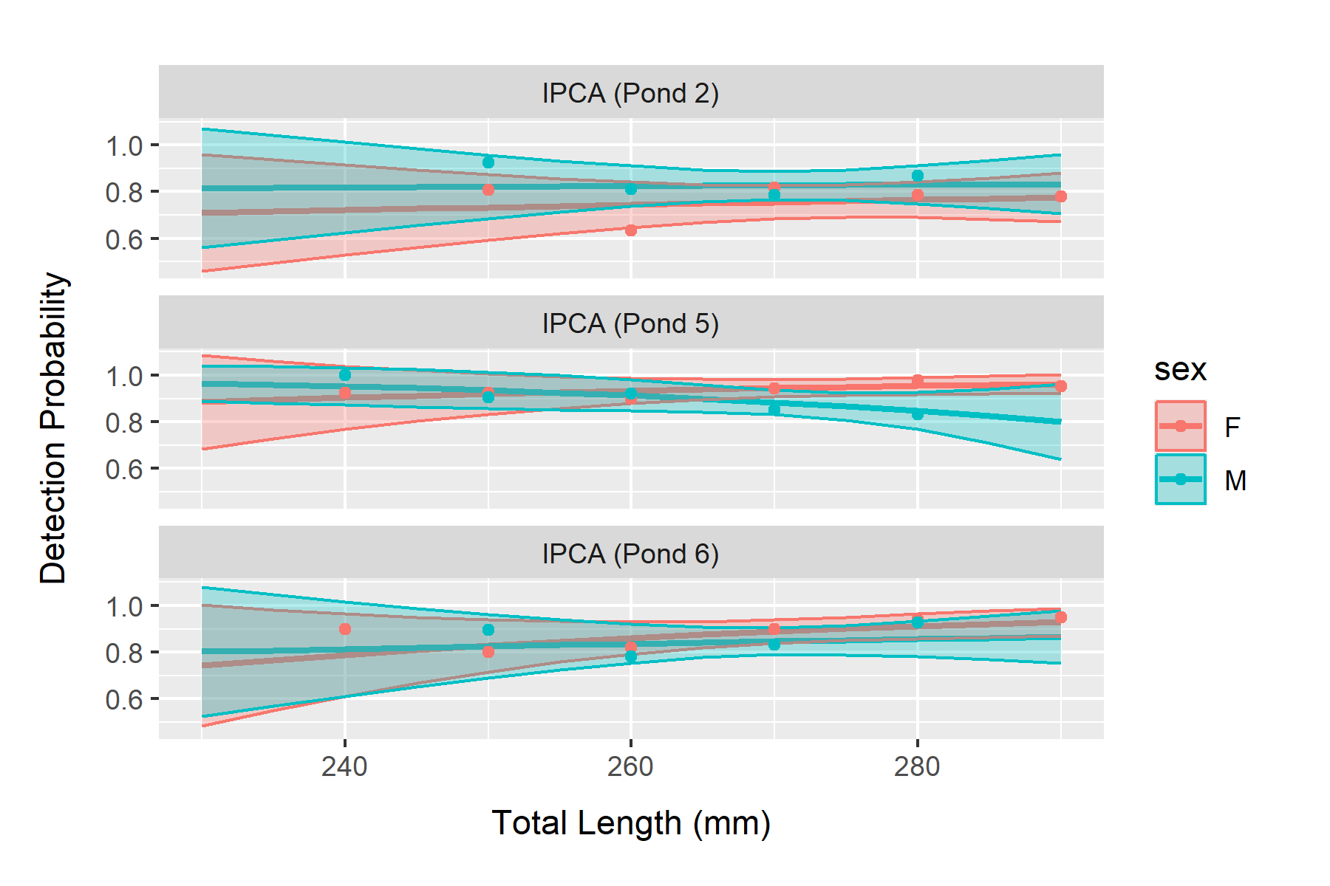

The discrepancy in post-release detection probability for razorback sucker due to sex and release size continued for years based on known survival analysis, but additional losses to both sexes after the initial post-release period appeared to be unaffected by sex.
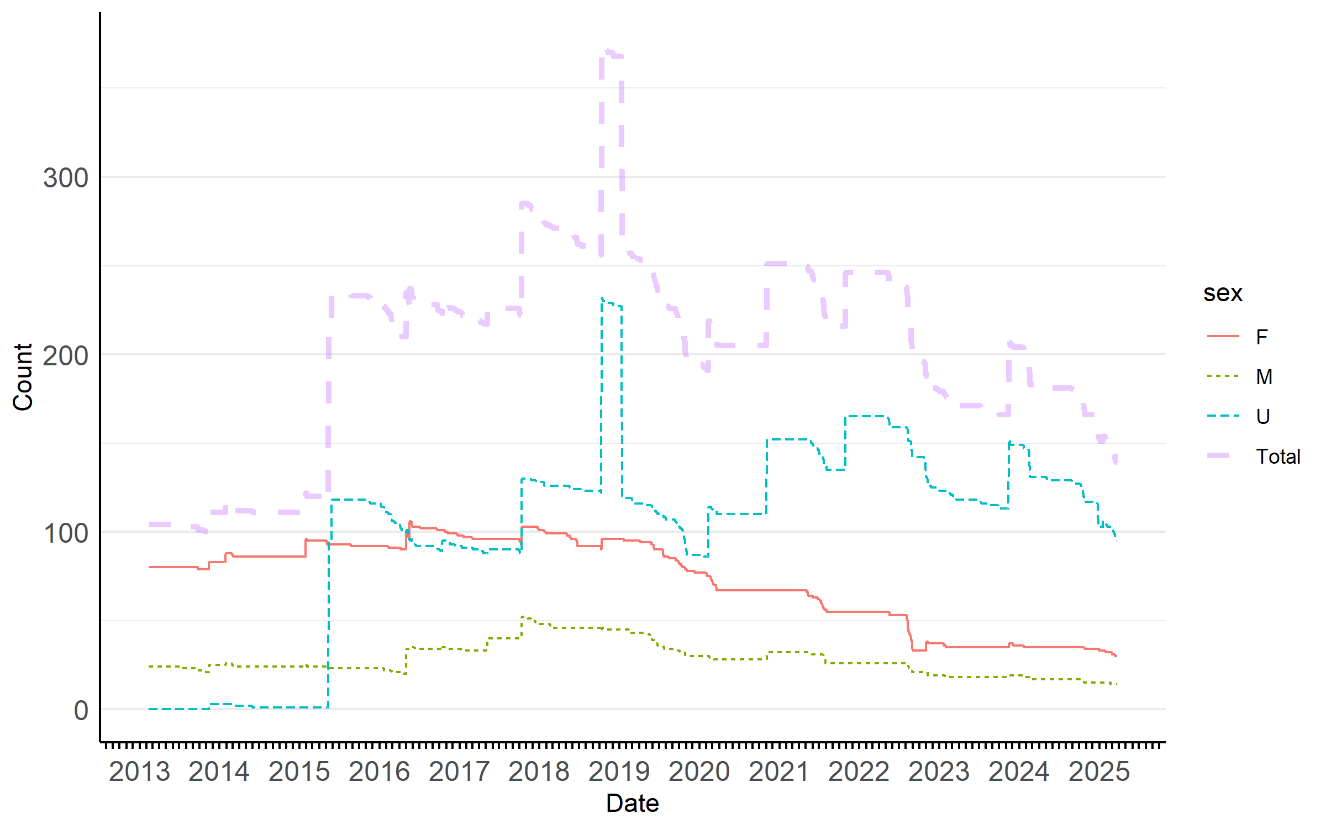

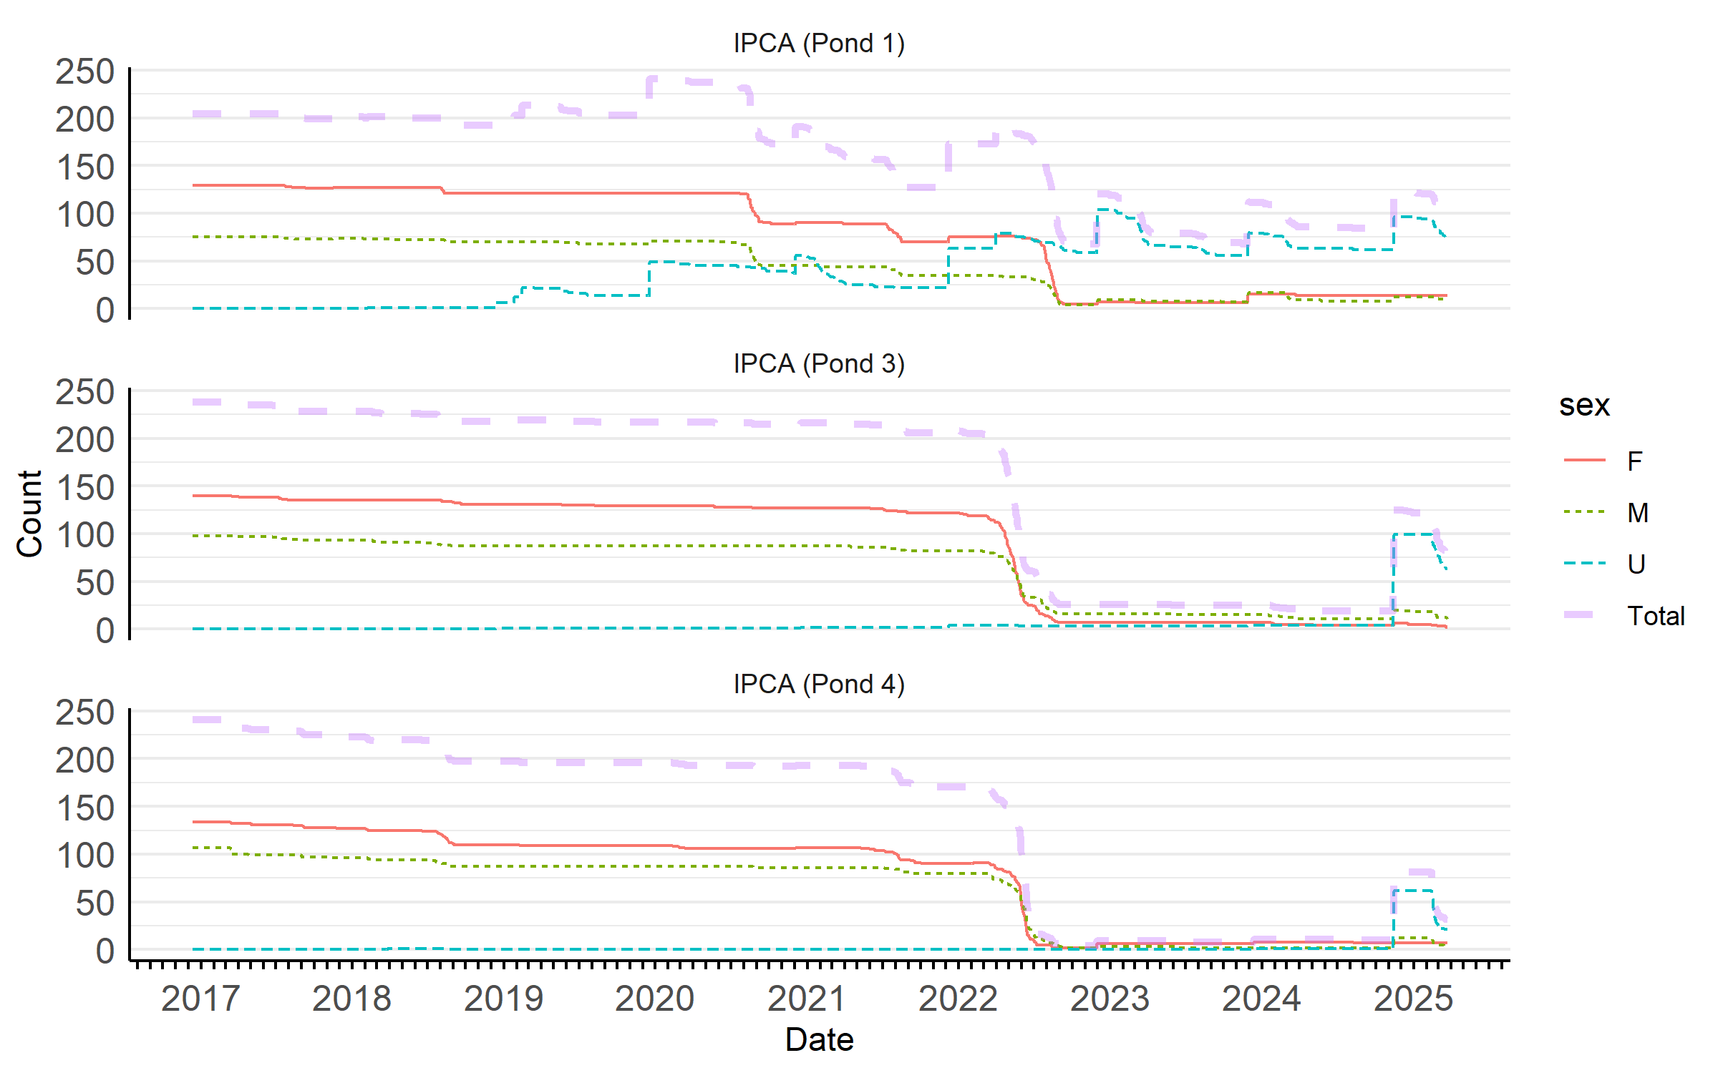

For bonytail, the initial high post-stocking detection probability did not persist, with longer term detection probability decreasing at a much higher rate than for razorback sucker.
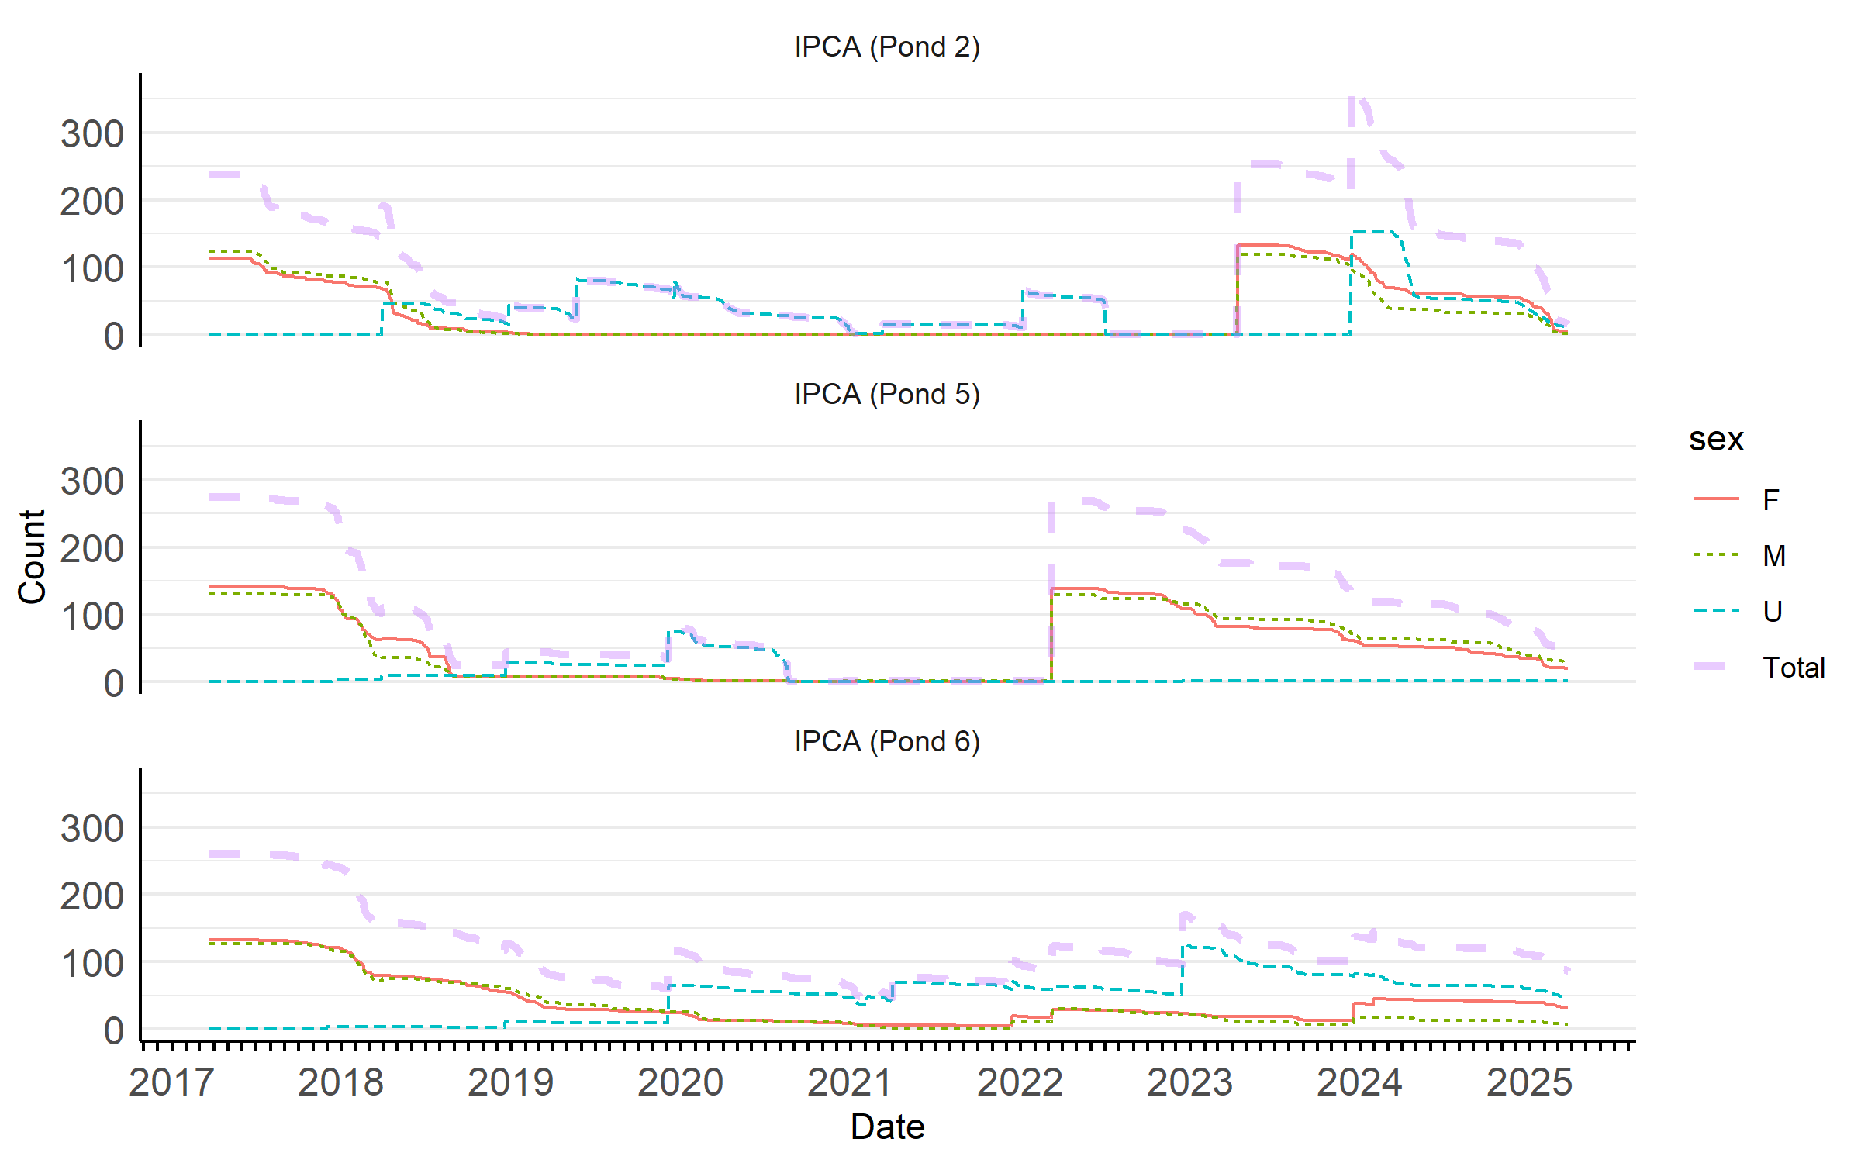

Mark-recapture estimates for tagged fish in all ponds overlap the know survivors plot when all sexes are combined.
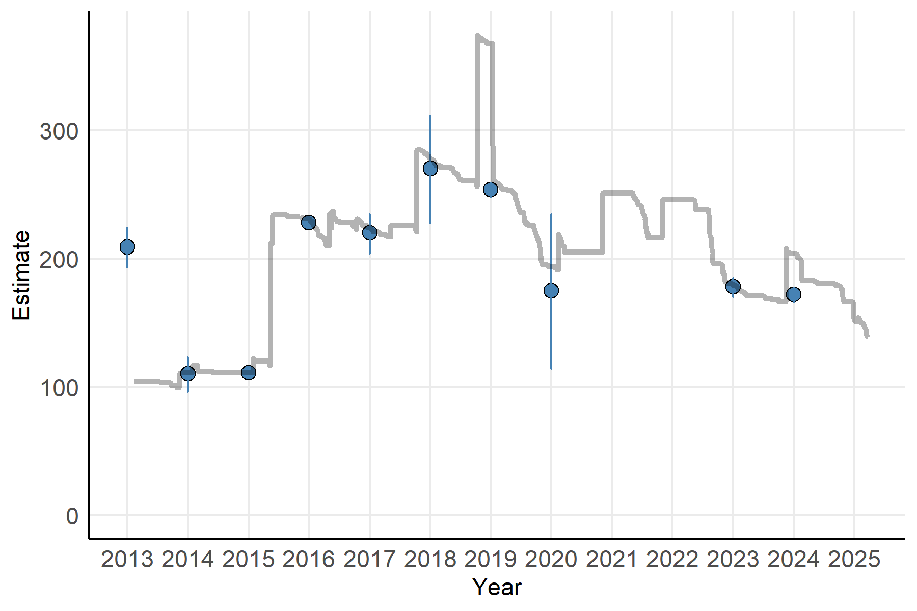
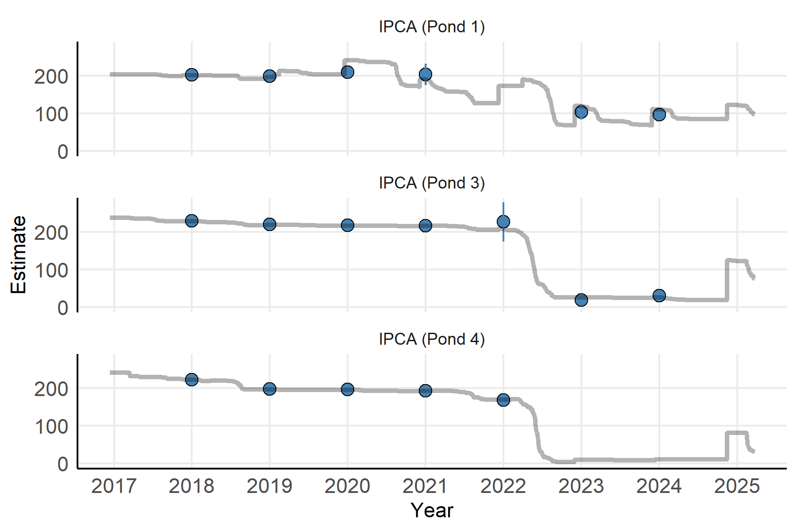

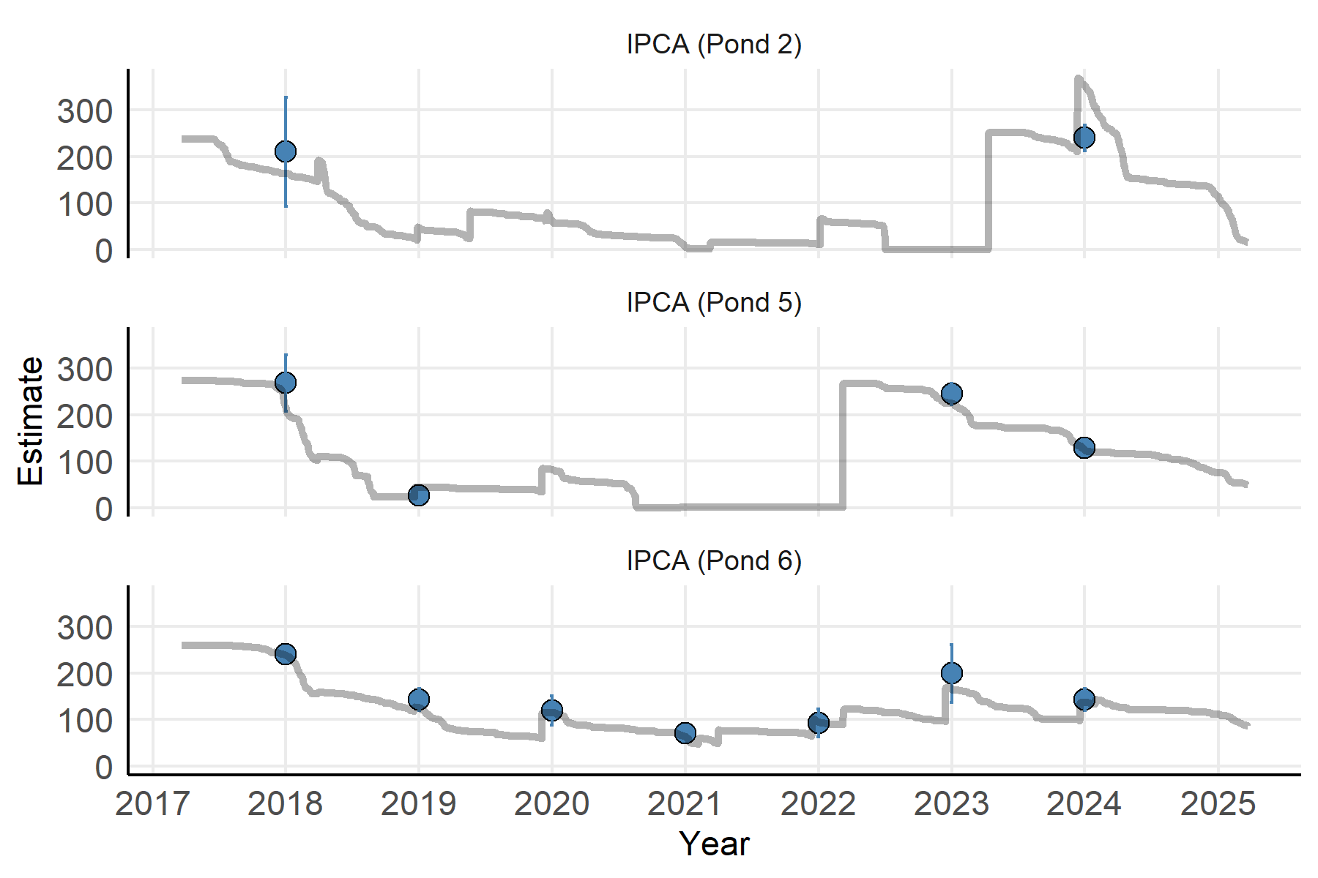

Downey, A.M., B.R. Kesner, P.C. Reap, C.A. Pacey, and P.C. Marsh. 2025. Demographics and Monitoring of Repatriated Razorback Suckers in Lake Mohave. 2020–2024 Final Project Report. Submitted to the Lower Colorado River Multi-Species Conservation Program, Bureau of Reclamation, Boulder City, Nevada, by Marsh & Associates, LLC, Tempe, Arizona, under contract No. 140R3020C0005

